**LAB # 04**

**Task # 01:** Write a program using the concepts of a default constructor. Consider a computer system whose name, type, processor specification, ram, hard disk drives, mother board, optical drive etc, in a default constructor, desired values are entered by the user in a get method (that takes information from the user) and the displays the inputted information via display method. The user shall be asked to change any of the provided information if he/she agrees to change the information then new values shall be asked from the user..

**Solution:**

**public static void main(String[] args)** {

Scanner input = new Scanner(System.in);

Computer c1 =new Computer();

System.out.println("By Default Specifications: ");

c1.display();

char re;

do { System.out.println("\nEnter your option: \n 1 for Inputting Data \n 2 for Display \n 3 for Update");

byte reply = input.nextByte();

switch(reply){

case 1:

c1.InputData();

break;

case 2:

c1.display();

break;

case 3:

c1.update();

break;

}

System.out.println("Do you want to perform again(y/n): ");

re=input.next().charAt(0);

} while (re=='y');

}

**public class Computer** {

Scanner input = new Scanner(System.in);

private String name;

private String type;

private String prospec;

private int ram;

private String hdd;

private String mb;

private String od;

public Computer(){

name ="HP";

type = "ProBook";

prospec= "i6";

ram = 8;

hdd= "350";

mb = "Asus";

od = "Intel";

}

public void InputData(){

char re;

do {

System.out.println("Enter the Name of Computer ");

String n = input.next();

this.name=n;

System.out.println("Enter the Type of Computer is ");

String t = input.next();

this.type = t;

System.out.println("Enter the Processors Specificaton: ");

String ps = input.next();

this.prospec= ps;

System.out.println("Enter the Ram of Computer is ");

int r =input.nextInt();

this.ram= r;

System.out.println("Enter the Harddisk Space of Computer ");

String hd = input.next();

this.hdd= hd;

System.out.println("Enter the Name of MotherBoard: ");

String m = input.next();

this.mb= m;

System.out.println("Enter Name of Optical Drive: ");

String o = input.next();

this.od=o;

System.out.println("Do you want to take more input(y/n): ");

re=input.next().charAt(0);

} while (re=='y');

}

public void display(){

System.out.println("\n*****************");

System.out.println("Name: "+name);

System.out.println("Type: "+type);

System.out.println("Pocessor Specification: "+prospec);

System.out.println("RAM: "+ram);

System.out.println("Hard Disk Drives: "+ hdd);

System.out.println("Motheboard: "+mb);

System.out.println("Optical Drive: "+od);

}

public void update(){

char re;

do {

System.out.println("\n");

System.out.println("What do you want to Update ? \n 1) for Name \n 2) for Type \n 3) for Pocessor Specification \n 4) for RAM \n 5) for Hard Disk Drive \n 6) for Motherboard \n 7) for Optical Drive");

int op= input.nextInt();

switch(op){

case 1:

System.out.println("Enter the Name of Computer ");

String n = input.next();

this.name=n;

break;

case 2:

System.out.println("Enter the Type of Computer is ");

String t = input.next();

this.type = t;

break;

case 3:

System.out.println("Enter the Processors Specificaton: ");

String ps = input.next();

this.prospec= ps;

break;

case 4:

System.out.println("Enter the Ram of Computer is ");

int r =input.nextInt();

this.ram= r;

break;

case 5:

System.out.println("Enter the space of Hard Disk Drive: ");

String hd = input.next();

this.hdd= hd;

break;

case 6:

System.out.println("Enter the Name of MotherBoard: ");

String m = input.next();

this.mb= m;

break;

case 7:

System.out.println("Enter Name of Optical Drive: ");

String o = input.next();

this.od=o;

break;

default:

System.out.println("Invalid Entry !");

break;

}

System.out.println("Do you want update more function(y/n): ");

re=input.next().charAt(0);

} while (re=='y');

}

**Output:**

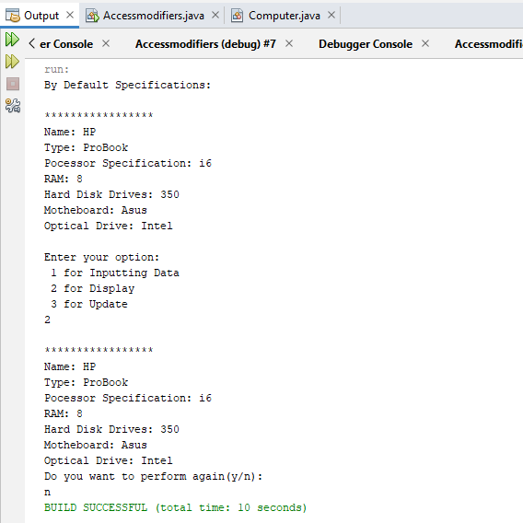

**Task # 02:** Use Constructor to set the radius and height of cylinder and calculate surface area and Volume of cylinder.

**Solution:**

**public static void main(String[] args)** {

Scanner input=new Scanner(System.in);

System.out.print("enter the radius of Cylinder: ");

int r=input.nextInt();

System.out.print("enter the height of Cylinder: ");

int h=input.nextInt();

Cylinder c=new Cylinder(r,h);

c.Display();

}

**public class Cylinder** {

int radius;

int height;

Cylinder(int r,int h){

radius=r;

height=h;

}

Double surfacearea(){

Double surfacearea;

surfacearea=2*Math.PI*radius*height+2*Math.PI*radius*radius;

return surfacearea;

}

Double volume(){

Double volume;

volume=Math.PI*radius*radius*height;

return volume;

}

void Display(){

System.out.println("-------- CYLINDER INFO ---------");

System.out.println("radius = "+ radius);

System.out.println("height = "+height);

System.out.println("Surface Area = "+surfacearea());

System.out.println("Volume = "+volume());

System.out.println("----------------------------------");

}

}

**Output:**

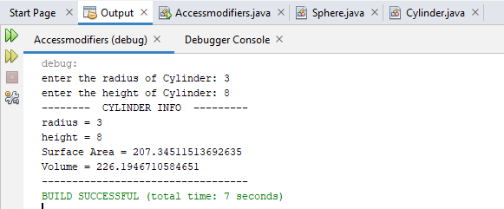

**Task # 03:** Use constructor overloading to initialize a rectangle of length 4 and breadth 5 for using custom parameters.

**Solution:**

**public static void main(String[] args)** {

System.out.println("----------- DEFAULT --------------");

Rectangle c=new Rectangle();

System.out.println("----- PASS ONE PARAMETER -----");

Rectangle c1=new Rectangle(2);

System.out.println("----- PASS BOTH PARAMETER -----");

Rectangle c2=new Rectangle(2,3);

System.out.println("-----------------------------------");

}

**public class Rectangle** {

int length=4;

int breath=5;

Rectangle(){

System.out.println("length = "+ length);

System.out.println("breath = "+breath);

}

Rectangle(int l){

length=l;

System.out.println("length = "+ length);

System.out.println("breath = "+breath);

}

Rectangle(int l,int b){

length=l;

breath=b;

System.out.println("length = "+ length);

System.out.println("breath = "+breath);

}

}

**Output:**

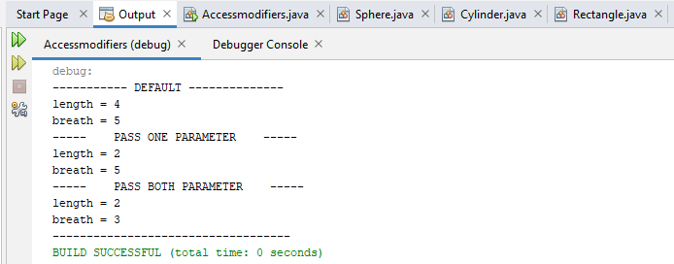

**Task # 04:** Design then implement a class to represent a **Flight**. A Flight has a *flight number*, a *source*, a *destination* and a *number of available seats. This* should be implemented using proper access modifier. The class should have:

1. A **constructor** to initialize the 4 instance variables. You have to shorten the name of the source and the destination to 3 characters only if it is longer than 3 characters by a call to the method in the ‘h’ part.
2. An **overloaded constructor** to initialize the *flight number* and the *number of available seats* instance variables only.

(**NOTE:** Initialize the *source* and the *destination* instance variables to empty string, i.e." ")

1. An **overloaded constructor** to initialize the *flight number* instance variable only.

(**NOTE:** Initialize the *source* and the *destination* instance variables to empty string; and the *number of available seats* to zero)

1. A **method** **public void reserve(int numberOfSeats)** to reserve seats on the flight. (**NOTE:** You have to check that there is enough number of seats to reserve)
2. A **method** **public void cancel(int numberOfSeats)** to cancel one or more reservations
3. A **toString** method to easily return the flight information as follows:

**Flight No: 1234**

**From: KAR**

**To: LAH**

**Available Seats: 18**

1. An **equals** method to compare 2 flights.

(**NOTE:** 2 Flights considered being equal if they have the same flight number)

1. The following method:

**private String shortAndCapital (String name) {**

**if (name.length() <= 3) {**

**return name.toUpperCase();**

**} else {**

**return name.substring(0,3).toUpperCase();**

**}**

**}**

**Write a test class for the *Flight* class you wrote. You should try to use all the methods you wrote.**

**Solution:**

**public static void main(String[] args)** {

Scanner s=new Scanner(System.in);

int num,seats;

String source,dest;

char reply,again;

Flight f1=new Flight(12,12,"karachi","islamabad");

Flight f2=new Flight();

System.out.println("Do you want to some changing in flight (y/n)");

again=s.next().charAt(0);

if (again=='y'||again=='Y')

{

do {

System.out.println("======Flight Reservation====");

System.out.println("Press 1)For Enter Flight No,Source,Destination,Avaliable Seats");

System.out.println("Press 2)For Enter Flight No,Avaliable Seats only");

System.out.println("Press 3)For Enter Flight No only");

System.out.println("Press 4)For Reserve Seats");

System.out.println("Press 5)For Cancel Seats");

reply=s.next().charAt(0);

if(reply=='1') {

System.out.println("Enter Flight Number");

num=s.nextInt();

System.out.println("Enter source");

source=f2.shortlong(s.next());

System.out.println("Enter Destination");

dest=f2.shortlong(s.next());

System.out.println("Enter Avaliable Seats");

seats=s.nextInt();

f2=new Flight(num,seats,source,dest);

}

else if(reply=='2') {

System.out.println("Enter Flight Number");

num=s.nextInt();

System.out.println("Enter Avaliable Seats");

seats=s.nextInt();

f2=new Flight(num,seats);

}

else if(reply=='3') {

System.out.println("Enter Flight Number");

num=s.nextInt();

f2=new Flight(num);

}

else if(reply=='4') {

System.out.println("Which seat do you want to reserve");

num=s.nextInt();

f2.reverse(num);

}

else if(reply=='5') {

System.out.println("Which seat do you want to cancel");

num=s.nextInt();

f2.cancel(num);

}

System.out.println("Do you want to again changing(y/n)");

again=s.next().charAt(0);

} while (again=='y'||again=='Y');

}

System.out.println("Do you want to Compare Flights(y/n)");

again=s.next().charAt(0);

if(again=='y'||again=='Y') {

System.out.println("Enter Flight No 1");

int a=s.nextInt();

System.out.println("Enter Flight No 2");

int b=s.nextInt();

f2.equals(a,b);

}

System.out.println("Good Luck");

System.out.println("Flight 1");

f1.display();

System.out.println("Flight 2");

f2.display();

}

**public class Flight** {

private int flight_no;

private String source;

private String destination;

private int seat;

Flight() {

flight_no=786;

seat=100;

source="KHI";

destination="ISL";

display();

}

Flight(int f,int se,String s,String d) {

this.flight_no=f;

this. seat=se;

this. source=shortlong(s);

this.destination=shortlong(d);

}

Flight(int f,int n) {

this.flight_no=f;

this.seat=n;

this.destination="";

this.source="";

}

Flight(int f) {

this.flight_no=f;

this.seat=0;

this.destination="";

this.source="";

}

public String shortlong(String s) {

if(s.length()<=3)

{

return s.toUpperCase();

}

else{

return s.substring(0, 3).toUpperCase();

}}

public void reverse(int Seat){

if(Seat<=seat)

{

System.out.println("Your Seat are Reserved");

}

else

{

System.out.println("Sorry there is enought number of seat");

seat-=Seat;

}

}

public void cancel(int Seat) {

seat+=Seat;

System.out.println("Your seat are cancel");

}

public void equals(int a,int b) {

if(a==b)

{

System.out.println("Flight number are same ");

}

else

{

System.out.println("Flight number are not same ");

} }

public void display() {

System.out.println("********=======********");

System.out.println("Flight No:"+flight_no);

System.out.println("Source:"+source);

System.out.println("Destination:"+destination);

System.out.println("Avaliable Seat:"+seat);

System.out.println("********=======********");

}}

**Output:**

